**Hypothesis Testing:**

* Ultimate goal is to make a concluding statement about the population parameter based on sample evidence.
* Statistical procedure that uses sample evidence and probability theory to determine whether a statement about the value of a population parameter (mean, proportion, etc):
* “should be rejected” = REJECT
* “should not be rejected” = FAIL TO REJECT

Example:

We want to test the claim made in a current report that ***the average yearly salary earned by full-time Realtors is $85,000 with a standard deviation of $12,540.***

However, a researcher believes that: ***The average full-time Realtor makes more than $85,000. In order to test his hypothesis he wants to conduct a test at a 95% confidence level****.*

The researcher takes a random sample of 36 Full-Time Realtors (n=36) and get a sample mean salary of $88,595 ().

We must decide if the sampling error of $3,595 ($88,595 – $85,000) is *acceptable.*

In other words, is the difference between the population mean and the sample mean **statistically significant**?

Null Hypothesis

Setting up a hypothesis test

Alternative Hypothesis

: Null Hypothesis: The default hypothesis or currently accepted value for a parameter. “What has been established”.

**Realtor’s average salary is $85,000.**

: Alternative Hypothesis: The research hypothesis. “Our research question”.

**Realtor’s average salary is more than $85,000**

**Mathematical Conversion:**

:

:

Important notes:

* in are mathematical opposites.
* Equality always found in
* sign tells us the type of test we will be conducting.
* Often easier to start writing the first.

Your Turn!

Write the null and alternative hypothesis for the following statements:

1. It is believed that a machine prints 5 copies per minute. After the machine has been serviced, the printing associates believe that the machines no longer prints 5 copies per minute.
2. Doctors believe that the average US worker is at the office on average no longer than 8 hours per day. A researcher believes that the average US worker is in the office longer than 8 hours per day.
3. FT Realtors make more than an average of $85,000 yearly

**: FT Realtors make more than an average of $85,000 yearly.**

:

:



**: FT realtors makes less than an average of $85,000 per year.**

:

:



**: FT realtors do not make an average of $85,000 per year.**

:

:



Recall:

We want to test the claim made in a current report that ***the average yearly salary earned by full-time Realtors is $85,000 with a standard deviation of $12,540, with the premise that FT Realtors make more than an average of $85,000.***

The researcher takes a random sample of 36 FT Realtors (n=36) and gets a sample mean salary of $88,595 ().

Conducting a hypothesis test using the **Critical Value Method: Right-Tailed Test**

: n= 36

: = $88,595



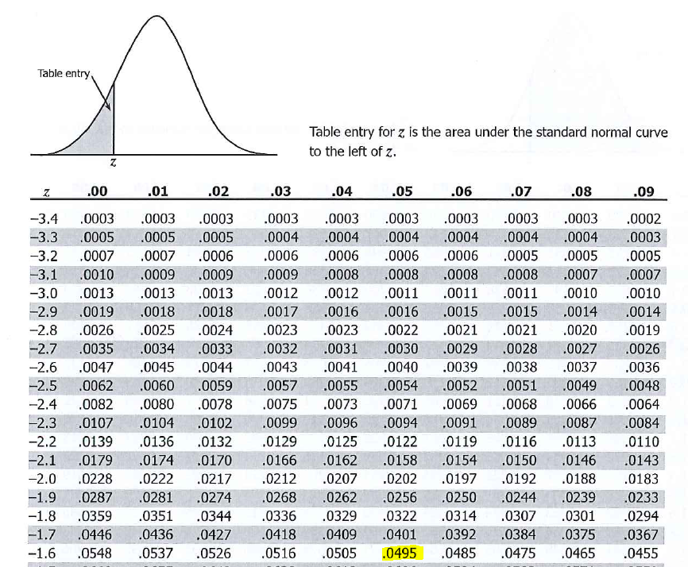

We want to test the claim made in a current report that ***the average yearly salary earned by full-time Realtors is $85,000 with a standard deviation of $12,540, with the premise that FT Realtors do not make an average of $85,000.***

The researcher takes a random sample of 36 FT Realtors (n=36) and gets a sample mean salary of $84,195 ().

Conducting a hypothesis test using the **Critical Value Method: Two-Tailed Test**

:

: n= 36

= $84,195



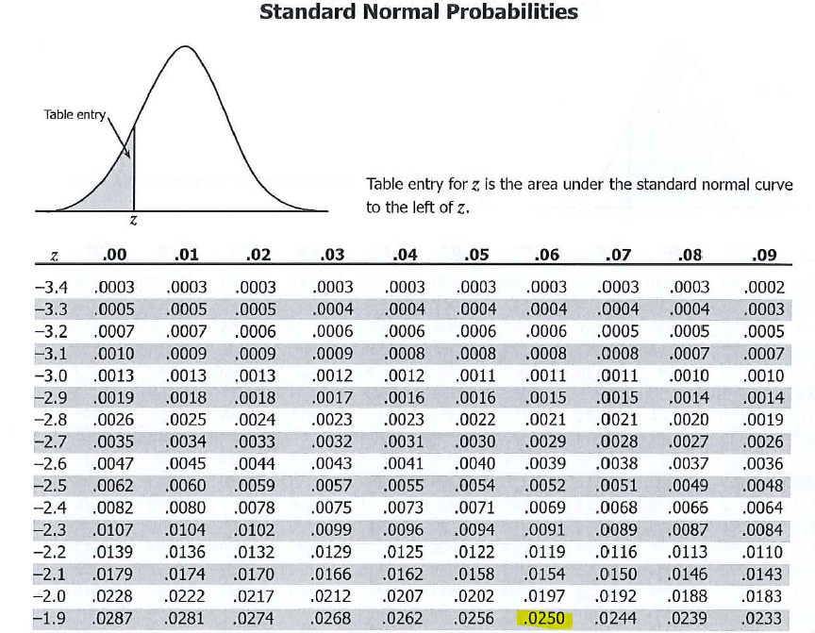

Conducting a hypothesis test using the **P-Value Method: Right-Tailed Test**

**Rule: reject *H*0 if the *p*-value < *a***

**Recall our Test Statistic: Z-Score: 1.72**

: n= 36

: = $88,595

Conducting a hypothesis test using the **P-Value Method: Two-Tailed Test**

**Recall our Test Statistic: Z-Score: -0.38**

:

: n= 36

= $84,195